***CRM Application for Jewel Management - (Developer)***

***COLLEGE NAME : VET INSTITUTE OF ARTS & SCIENCE***

***COLLEGE CODE : brubb***

***Team ID : NM2025TMID25636***

***Team Leader : KAVYA SHREE K***

***EMAIL :***[***kavyashreek23cse@vetias.ac.in***](mailto:kavyashreek23cse@vetias.ac.in)

***Team Member 1: AISHWARYA E***

***EMAIL :***[***aishwaryae23cse@vetias.ac.in***](mailto:aishwaryae23cse@vetias.ac.in)

***Team Member 2: KARTHICK S***

***EMAIL :***[***karthicks23cse@vetias.ac.in***](mailto:karthicks23cse@vetias.ac.in)

***Team Member 3: MOHAMED MARZOOK E S***

***EMAIL :***[***mohamedmarzookes23cse@vetias.ac.in***](mailto:mohamedmarzookes23cse@vetias.ac.in)

***Team Member 4: SANJEEV M***

***EMAIL :***[***sanjeevm23cse@vetias.ac.in***](mailto:sanjeevm23cse@vetias.ac.in)

**Project Overview:**Jewelry businesses face challenges in managing customer preferences, inventory, billing, and after-sales services. This project leverages Salesforce CRM to build an application that streamlines customer relationship management, sales tracking, and inventory handling for jewelry shops. The system connects customers, sales staff, and administrators on a single platform to enhance operational efficiency and customer satisfaction.

**Objectives:**

**Customer Management:** Maintain detailed customer profiles including purchase history, preferences, and loyalty points.

**Inventory Tracking:** Monitor stock availability in real-time to prevent shortages and overstock.

**Sales Automation:** Automate quotation generation, billing, and follow-up reminders.

**Analytics & Reporting:** Generate dashboards and reports for sales, customer trends, and revenue insights.

**Operational Efficiency:** Streamline workflows for sales staff and managers, saving time and reducing error

**Enhanced Customer Engagement:** Provide personalized offers and notifications to strengthen customer loyalty.

**Student Outcomes:**

**Hands-on Salesforce Development:** Gain experience in creating custom objects, fields, relationships, flows, and triggers specific to jewelry business needs.

**End-to-End CRM Project Understanding:** Learn the full cycle from requirement gathering to deployment in a real-world business use case

.

**Analytical & Problem-Solving Skills:** Develop the ability to analyze business challenges and design Salesforce-based solutions.

**Collaboration & Documentation Skills:** Work as a team to plan, build, test, and document CRM functionalities.

**Industry Exposure:** Understand how CRM systems like Salesforce are applied to retail and luxury industries, building career readiness.

**Practical Experience with Dashboards & Reports:** Learn to create visual reports to support decision-making in sales and customer management.

**System Requirements:**

**Hardware Requirements:**

* Computer with minimum 4 GB RAM, Dual-core processor
* Stable internet connection

**Software Requirements:**

* Salesforce Developer Edition Org
* Modern Web Browser (Google Chrome, Firefox, or Edge)

**Project Duration:**31 hours

**Phase Overview**

| Phase no | Phase Name | Description | Page No |
| --- | --- | --- | --- |
| 1 | Requirement Analysis & Planning | Gathering requirements from customers, service advisors, mechanics, and managers; defining scope and goals; planning data model and workflows | 5 |
| 2 | Salesforce Development – Backend & Configurations | Creating custom objects, fields, and relationships; setting up Flows and Apex Triggers for service job automation and inventory tracking. | 5-12 |
| 3 | UI/UX Development & Customization | Building Lightning App, customizing layouts, adding fields for vehicle details, service history, and implementing UI logic and Flows. | 12-26 |
| 4 | Data Migration, Testing & Security | Creating Users, Profiles, Public Groups, Sharing Rules; configuring Report Types, Reports, Dashboards; testing functionalities and ensuring data security. | 26-37 |
| 5 | Deployment, Documentation & Maintenance | Designing and finalizing Home Page, deploying the garage system to the live environment, preparing documentation, conclusion, and ongoing maintenance. | 37-45 |

**Phase 1:Requirement Analysis & Planning**

**JEWELLERY MANAGEMENT**

Leveraging Salesforce, our project enhances jewelry operations by streamlining inventory management, customer tracking, and order processing — ensuring precision, efficiency, and full transparency in every aspect of the business."

**Phase 2: Salesforce Development – Backend & Configurations:-**

**Milestone 1: Salesforce developer account creation**

**ACTIVITY 1: Creating Developer Account**

Creating a developer org in salesforce.

1. Go to https://developer.salesforce.com/signup

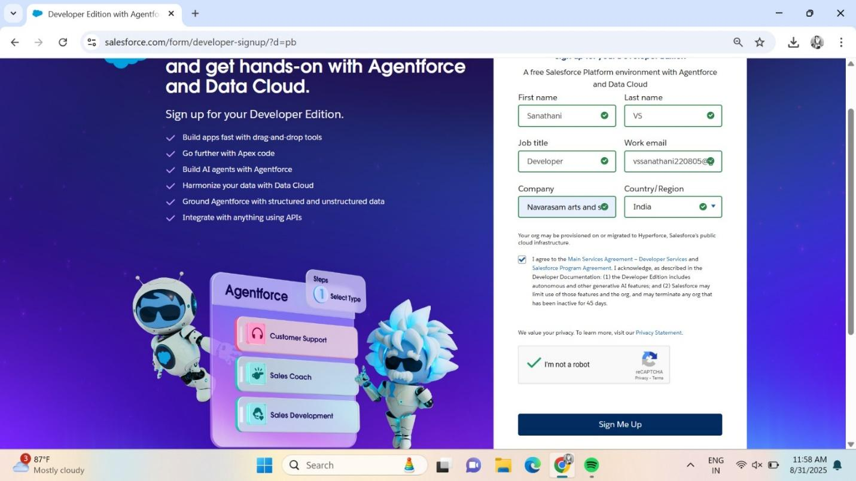

2. On the sign up form, enter the following details :

1. First name & Last name

2. Email

3. Role : Developer

4. Company : College or Company Name

5. Country : India

6. Postal Code : pin code

7. Username : should be a combination of your name and company

**ACTIVITY 2:Account Activation**

1. Go to the inbox of the email that you used while signing up. Click on the Reset Password to activate your account. The email may take 5-10mins.

2. Click on Reset Password

3. Give a password and answer a security question and click on change password.



1. Then you will redirect to your salesforce setup page.



**Milestone 2:OBJECTS**

**ACTIVITY 1:CREATE JEWELLERY CUSTOM OBJECTS**

1. Go to Setup
   * Click the gear icon (top right corner).
   * Click "Setup."
2. Open Object Manager
   * In the Setup page, click "Object Manager" (top menu).
3. Create New Custom Object
   * Click "Create" → then click "Custom Object."
4. Enter Object Details
   * Label Name: Jewel Customer
   * Plural Label: Jewel Customers
5. Set Record Name
   * Record Name: Customer name
   * Data Type: Text
6. Check These Options
   * Allow Reports
   * Allow Search
7. Click Save

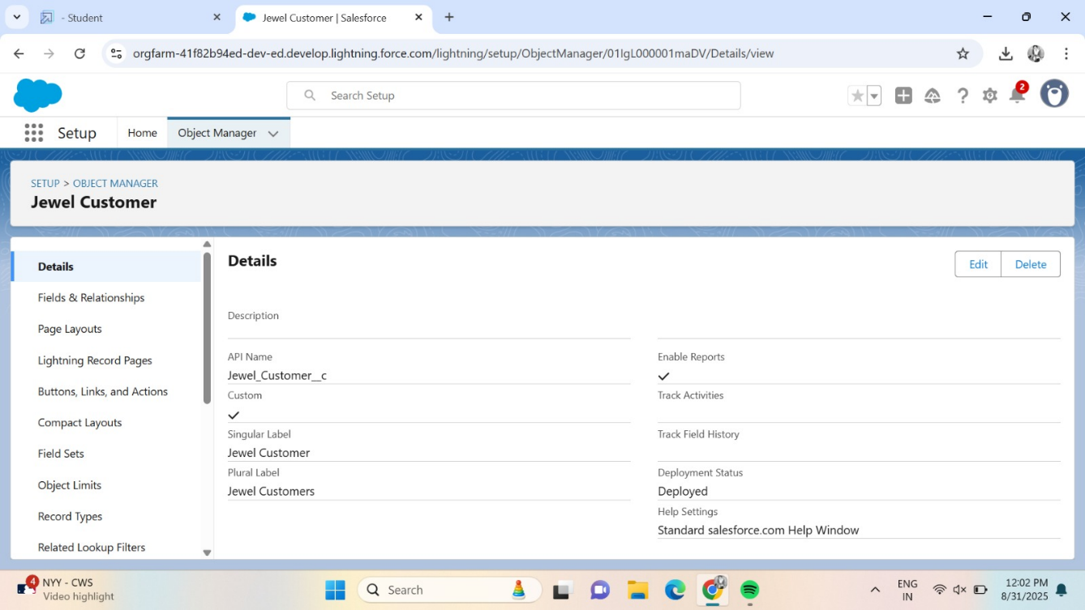

**ACTIVITY 2:CREATE ITEM OBJECT**

1.Go to Setup

* Click the gear icon (top right)
* Select "Setup"

2. Open Object Manager

* Click on "Object Manager" (top menu)

3. Create a New Custom Object

* Click "Create"
* Choose "Custom Object"

4. Enter Object Details

* Label Name: Item
* Plural Label: Items

5. Set Record Name

* Record Name: Item Id
* Data Type: Auto Number
* Display Format: Item{00}
* Starting Number: 1

6.Check These Options

* Allow Reports
* Allow Search

7.Click Save

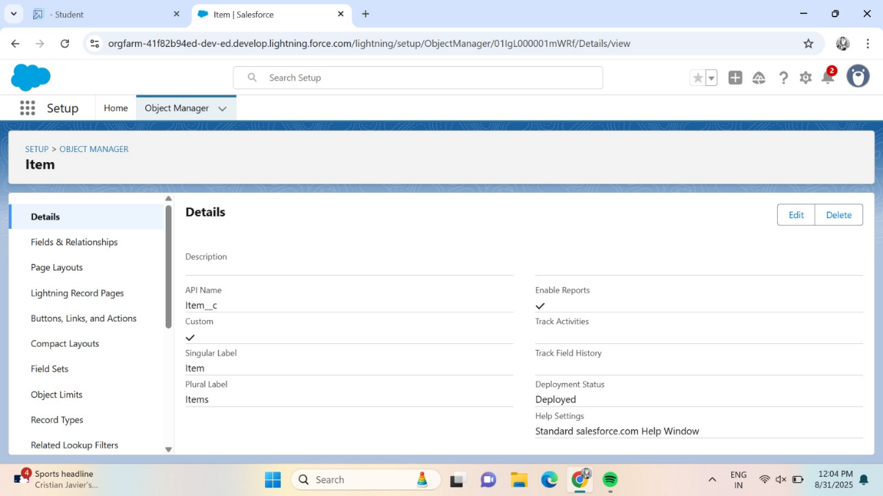

**Milestone 3:TABS**

**ACTIVITY 1:CREATING A CUSTOM TABS**

1. Go to Setup

* Click the gear icon (top right)
* Click "Setup"

2. Search for Tabs

* In the Quick Find search bar (left side), type "Tabs"
* Click on "Tabs" from the results

3. Create a New Tab

* Find "Custom Object Tabs" section
* Click on the "New" button

4. Fill in Tab Details

* Select Object: Choose "Jewel Customer"
* Tab Style: Pick any icon/style you like (e.g., Diamond, Star)

5. Click Next

* Leave the Add to Profiles page as default
* Click Next again to go to the Custom App page
* Leave this as default too

6. Click Save

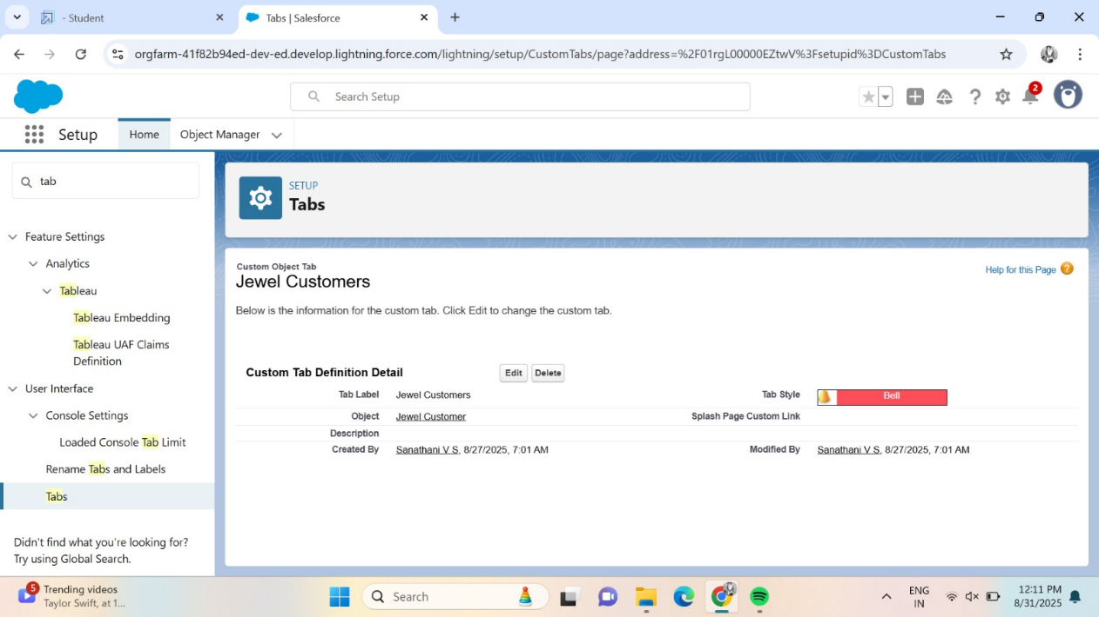

**ACTIVITY 2:TO CREATE A TAB:(ITEM)**

1. Go to Setup

* Click the gear icon (top right)
* Click "Setup"

2. Search for Tabs

* In the left search bar (Quick Find), type "Tabs"
* Click on "Tabs"

3. Create a New Tab

* Under "Custom Object Tabs", click "New"

4. Select Object

* From the dropdown, choose "Item"

5. Choose a Tab Style

Pick any icon you like (e.g., box, gold bar, etc.)

6. Click Next (twice)

* Keep everything default on both pages:
  + Add to Profiles page → Default
  + Add to Custom App page → Default

7. Click Save

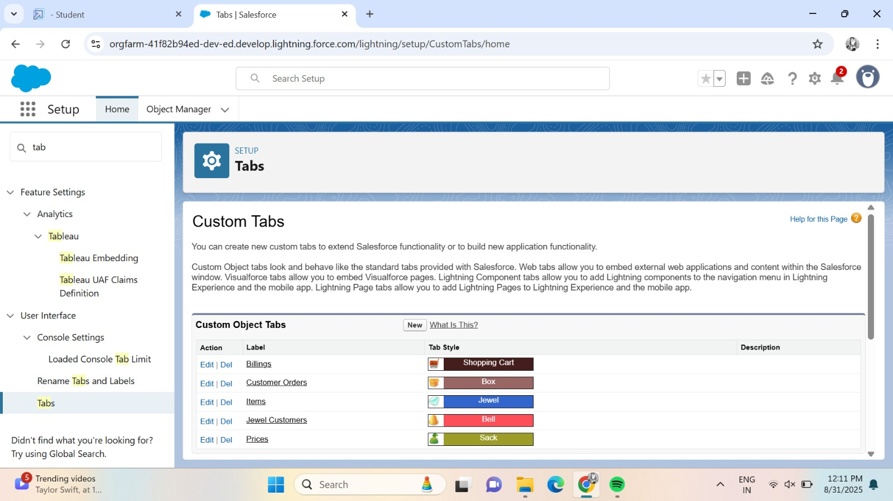

**PHASE 3:** UI/UX Development & Customization

**Milestone 4: The Lightning App**

**ACTIVITY 1:CREATE A LIGHTNING APP**

### 1. **Go to Setup**

* Click the gear icon (top right)
* Click "Setup"

### 2. **Search for App Manager**

* In the Quick Find bar (left side), type: App Manager
* Click on "App Manager"

3. Create New Lightning App

* Click the "New Lightning App" button (top right)

### 

### 4. **App Details & Branding**

* App Name: Jewellery Inventory System
* Developer Name: (This fills in automatically)
* Description: Elevate your look with elegance
* Image: (Optional – you can skip this)
* Primary Colour: Leave it as default
* Click Next

### 5. **App Options**

* Navigation Style: Choose Console Navigation
* Click Next

### 6. **Utility Items**

* Keep everything default
* Click Next

### 7. **Add Navigation Items**

Now add the tabs you want to see in the app menu:

* In the Search bar, type and find the following one by one:
  + Jewel Customer
  + Item
  + Customer Order
  + Price
  + Bill
  + Reports
  + Dashboard
* Select each one and click the right arrow to move them to the selected list
* Click Next

### 8. **Assign User Profiles**

* In the search bar, type: System Administrator
* Select it and click the right arrow to add it,save & finish

**Milestone 5 : FIELDS**

**ACTIVITY 1:CREATING LOOKUP RELATIONSHIP**

### 1. **Go to Setup**

* Click thegear icon(top right)
* Click"Setup"

### 2. **Open Object Manager**

* In the Quick Find bar, type: Customer Order
* Click on the Customer Order object from the list

### 3. **Go to Fields & Relationships**

* Click on "Fields & Relationships"
* Click on the "New" button

### 4. **Choose Relationship Type**

* Select "Lookup Relationship"
* Click Next

### 

### 5. **Select Related Object**

* From the list, choose: Jewel Customer
* Click Next

### 6. **Set Field Details**

* Field Label: Type Customer
* Click Next → Click Next again

### 7. **Save**

* Click Save to finish

### ACTIVITY 2:Creating a Master-Detail Relationship

1. Go to the setup page >> click on object manager >>  type object name(Customer Order) in the quick find bar >> click on the object.

2.Click on fields & relationships >> click on New.

3.Select “Master-Detail relationship” as data type and click Next.

4.Select the related object “ Item”.

5.Give Field Label as “Item” and click Next.

 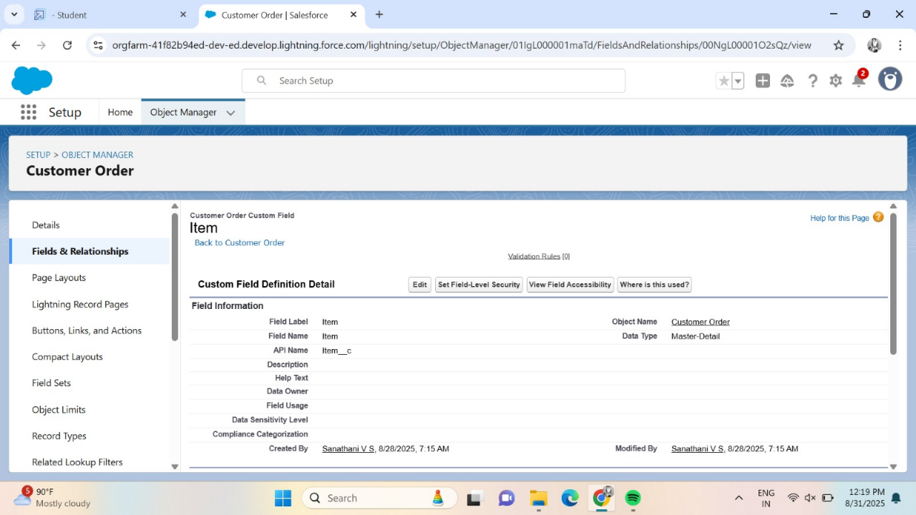

### ACTIVITY 3:Creating Text Field in Jewel Customer Object

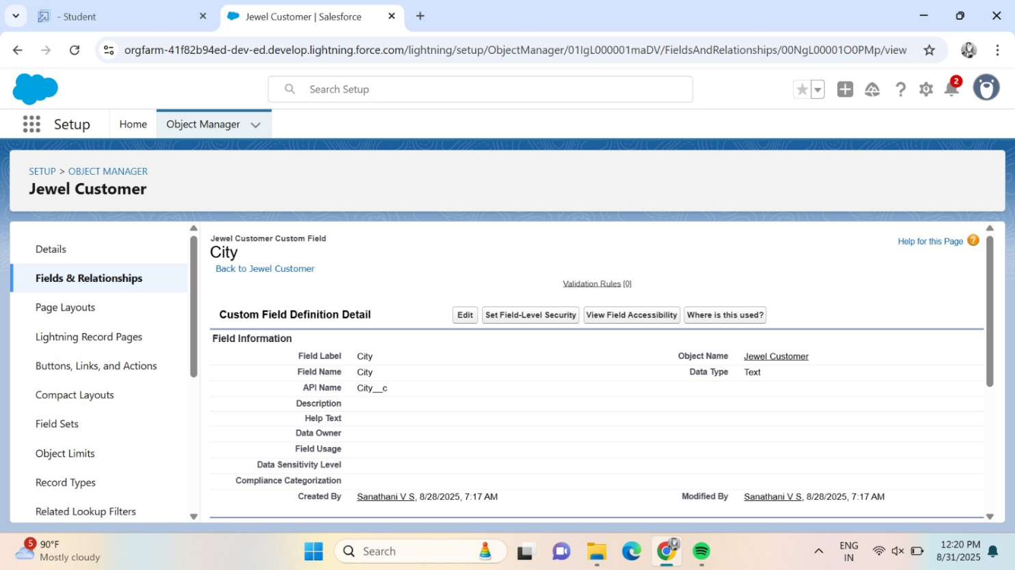

### ACTIVITY 4:Creating the Phone field in object Jewel Customer

### 

### ACTIVITY 5:Creating the Email field in object Jewel Customer

### 

### ACTIVITY 6:Creating Remaining Fields in Objects

### 

### ACTIVITY 7:Creating the number field in Item object

### 

### ACTIVITY 8:Creating Picklist Field in Item Object

### 

### ACTIVITY 9:Schema Bulider

### 

### ACTIVITY 10:Creating the Field Dependencies

### 

**ACTIVITY 11:Creating The Validation Rules**

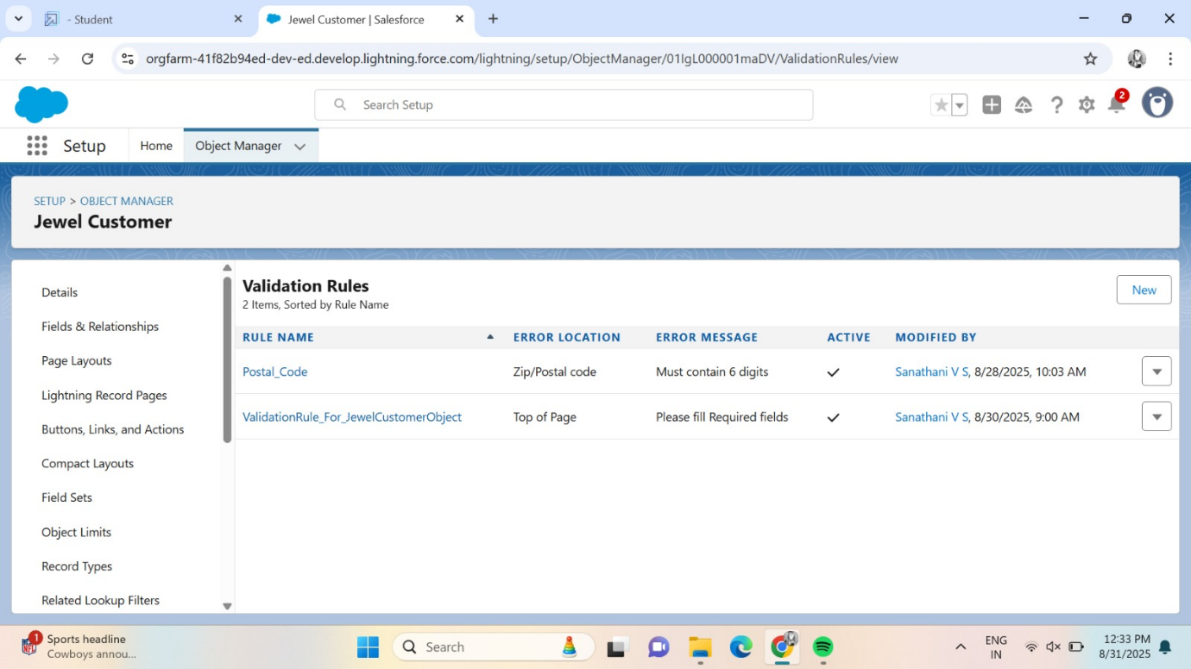

**Milestone 6: PROFILES**

**ACTIVITY 1:Gold Smith Profile**

Grant Custom Object Permission:

* + Scroll down to the section called Custom Object Permissions.
  + Give access (Check the boxes) for the following objects:
    - Jewel Customer
    - Item
    - Customer Order
    - Prices
    - Billings

**ACTIVITY 2:Worker Profile**

1. Go to Profiles:
   * In Salesforce, go to the Setup menu (the gear icon).
   * In the search box, type Profiles and click on it.
2. Clone a Profile:
   * Find the Salesforce Platform User profile (or any profile you want to copy).
   * Click on the profile and press Clone.
   * Give the new profile a name.
   * Click Save.
3. Edit the Profile:
   * After saving, click Edit on the profile page. 

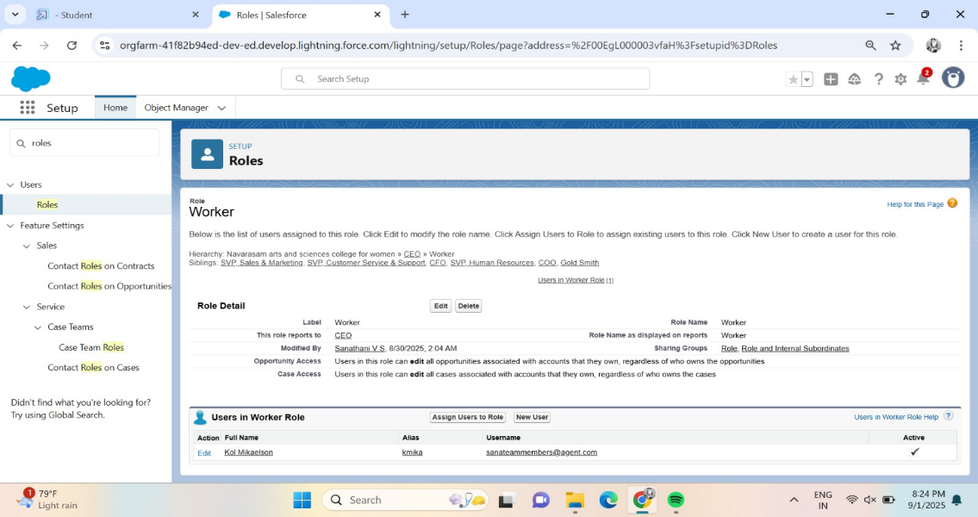

1. Grant Permissions: 
   * Scroll down to Custom Object Permissions.
   * Find the objects: Items, Price, and Customer Order.
   * Select the permissions you want to give (e.g., Read, Create, etc.).
2. Save Your Changes:
   * After selecting the permissions, scroll down and click Save.

**Milestones 7:ROLES**

**ACTIVITY 1:Changing Gold Smith Roles**

1. Go to Setup:
   * In Salesforce, go to the Setup area (top-right corner).
2. Search for Roles:
   * In the Quick Find box, type Roles and click on Roles under the "User Management" section.
3. Set Up Roles:
   * On the Roles page, click on Set Up Roles (you might see a button or a link).
4. Expand All:
   * Click on Expand All to see all the roles and structure.

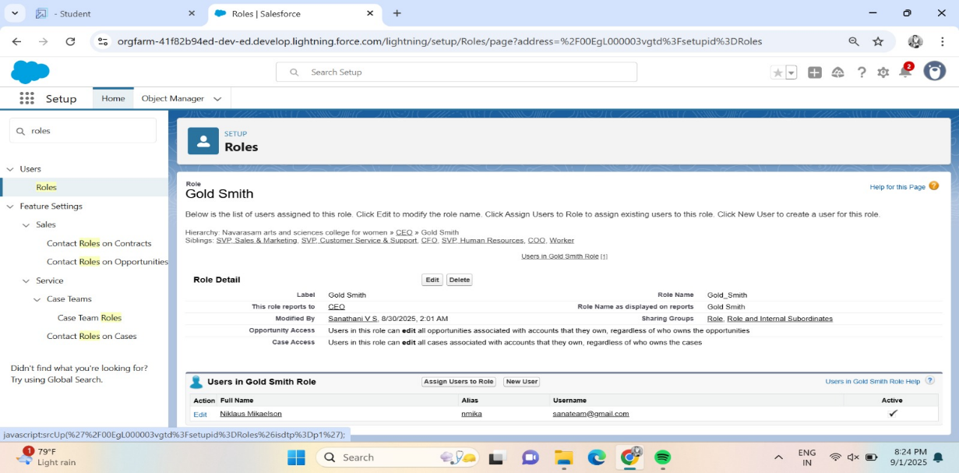

1. Add a New Role:
   * Click on Add Role under the section that shows where this new role will fit into the role hierarchy.
2. Enter Role Details:
   * Label: Type in Gold Smith (this is the name of the role).
   * The Role Name will automatically populate based on the label.
   * Reports To: Select the role to whom this Gold Smith role will report (this can be someone higher in the hierarchy like a manager or admin).
3. Save:
   * Once you've filled out the details, click Save to create the new Gold Smith role.

**ACTIVITY 2:Create One More Role As Worker Which Reports To Gold Smith**

1. Go to Setup:
   * In Salesforce, go to the Setup area (top-right corner).
2. Search for Roles:
   * In the Quick Find box, type Roles and click on Roles under the "User Management" section.
3. Set Up Roles:
   * On the Roles page, click on Set Up Roles (you’ll see a link or a button).
4. Expand All:
   * Click on Expand All to see all the roles and their hierarchy.
5. Add a New Role:
   * Click on Add Role under the section where you want to place the Worker role (it will be below the Gold Smith role).
6. Enter Role Details:
   * Label: Type in Worker (this is the name of the new role).
   * The Role Name will automatically fill in based on the label.
   * Reports To: From the dropdown, select Gold Smith (this makes the Worker role report to Gold Smith).
7. Save:
   * Once you've filled out the details, click Save to create the Worker role.

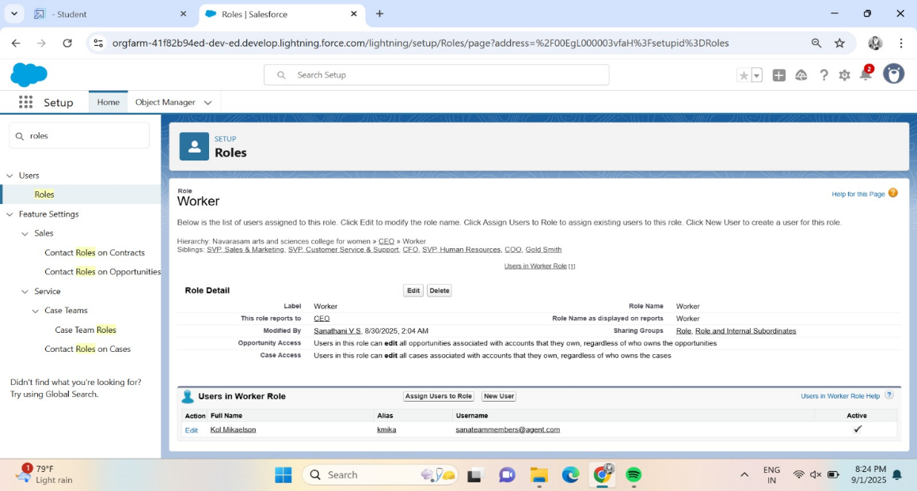

**PHASE 4:** Data Migration, Testing & Security

**Milestone 8:USERS**

**ACTIVITY 1:Create User**

1. Go to Users:
   * In Salesforce, go to the Setup menu (the gear icon).
   * In the search box, type Users and click on Users.
2. Create a New User:
   * On the Users page, click the New User button.
3. Fill in the Details:
   * First Name: Enter Niklaus.
   * Last Name: Enter Mikaelson.
   * Alias: Give a short name, like Nik or anything you prefer.
   * Email: Enter your personal email address.
   * Username: This should be in this format: text@text.text (e.g., niklaus.m@example.com).
   * Nickname: Enter a short nickname for the user (e.g., Nik).
   * Role: Select Gold Smith as the role.
   * User License: Choose Salesforce.
   * Profile: Select the Gold Smith profile.

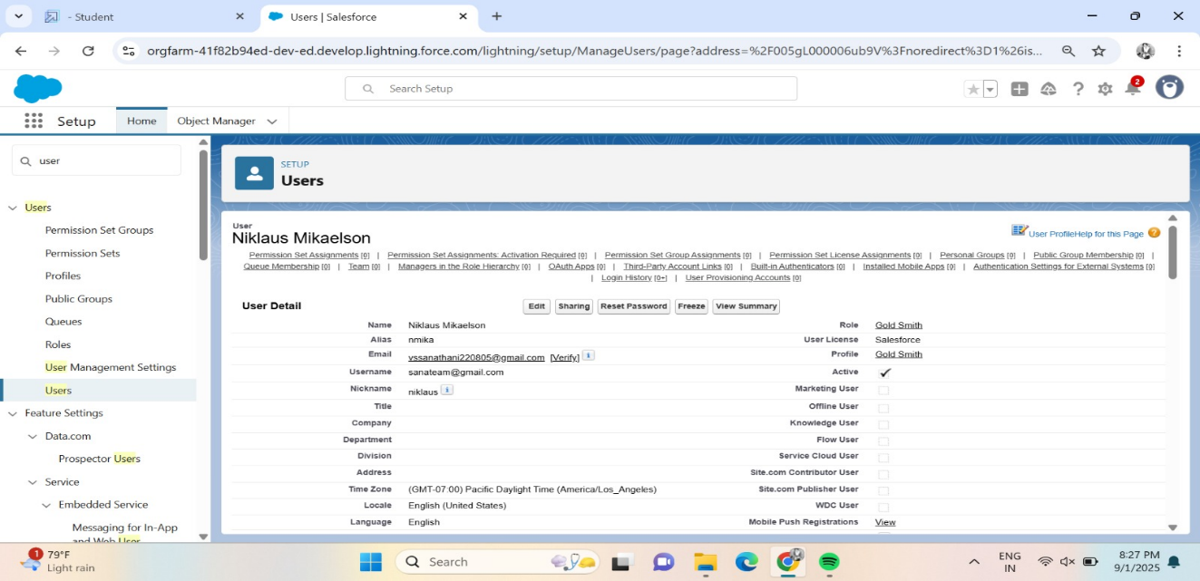

1. Save:
   * Once you've filled in all the fields, click Save to create the user.

**ACTIVITY 2:Create User**

1. Go to Setup:
   * In Salesforce, click on Setup (top-right corner).
2. Search for Users:
   * In the Quick Find box, type Users and click on Users under the "User Management" section.
3. Create New User:
   * On the Users page, click on New User (usually a button at the top of the page).

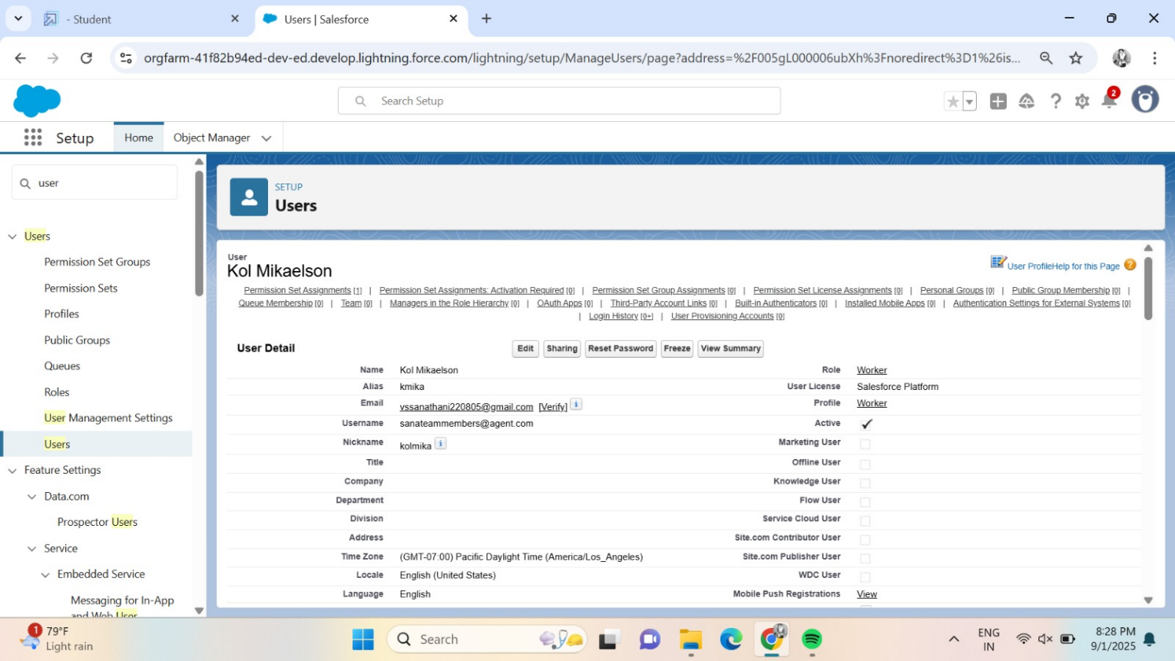

1. Fill in the User Details:
   * First Name: Type Kol.
   * Last Name: Type Mikaelson.
   * Alias: Enter an alias (a short name, like KolM or K.M).
   * Email ID: Enter your personal email address (for example, kol.m@example.com).
   * Username: Enter a username in this format: kol.mikaelson@example.com.
   * Nickname: Enter a nickname (like Kol or KM).
   * Role: Choose Worker (from the dropdown).
   * User License: Select Salesforce Platform.
   * Profile: Choose Worker (from the dropdown).
2. Save:
   * After filling in the details, click Save to create the user.

**PHASE 4:** Data Migration, Testing & Security

**Milestone:8 PAGE LAYOUT**

**ACTIVITY 1:To Create A Gold Page layout**

1. Go to Setup:
   * In Salesforce, click the gear icon in the top-right corner, then click Setup.
2. Find Object Manager:
   * In the left-hand search box, type Object Manager and click on it.
3. Search for the Object:
   * In the Object Manager page, type Item (or the name of your object) in the search bar and click on it.
4. Edit the Object:
   * In the Item object page, click Edit in the dropdown.
5. Create a New Page Layout:
   * Click on Page Layouts on the left side.
   * Now, click the New button to create a new layout.

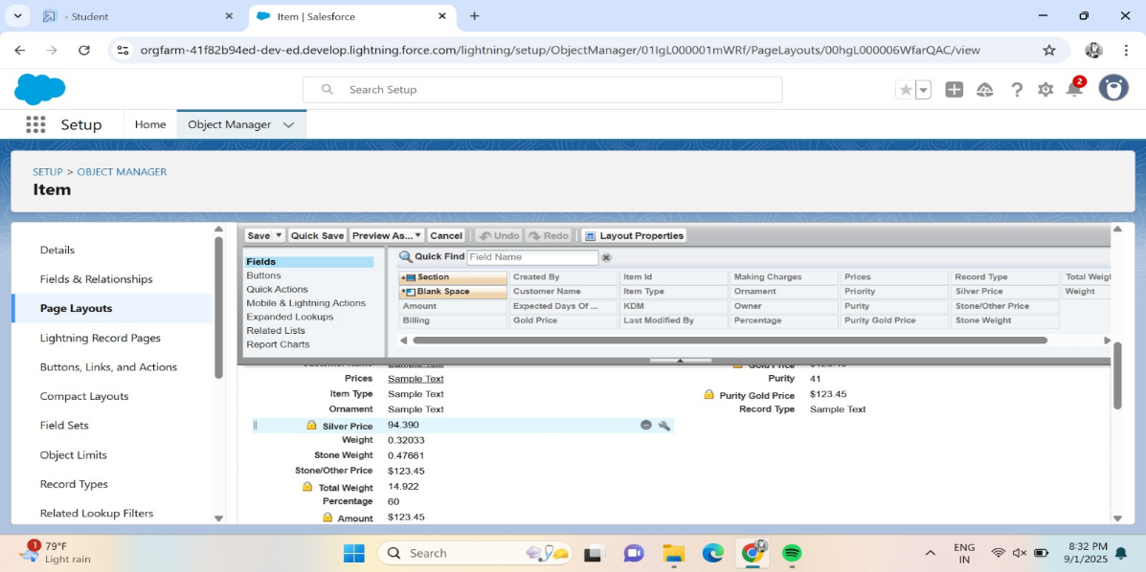

1. Name the Layout:
   * In the pop-up window, name your new layout "Page Layout for Gold".
   * Then, click Save and New.
2. Save the Layout:
   * Once you’ve made all changes and arranged the fields, click Save.

**ACTIVITY 2:To Create A Silver Plate Layout**

1. Go to Setup:
   * Click the gear icon at the top-right of Salesforce.
   * Select Setup from the dropdown.
2. Find Object Manager:
   * In the Quick Find box on the left, type Object Manager and click on it.
3. Edit the Object:
   * Once on the Item page, click the dropdown next to it and select Edit.
4. Create a New Page Layout:
   * In the left sidebar, click on Page Layouts.
   * Click the New button to create a new layout.

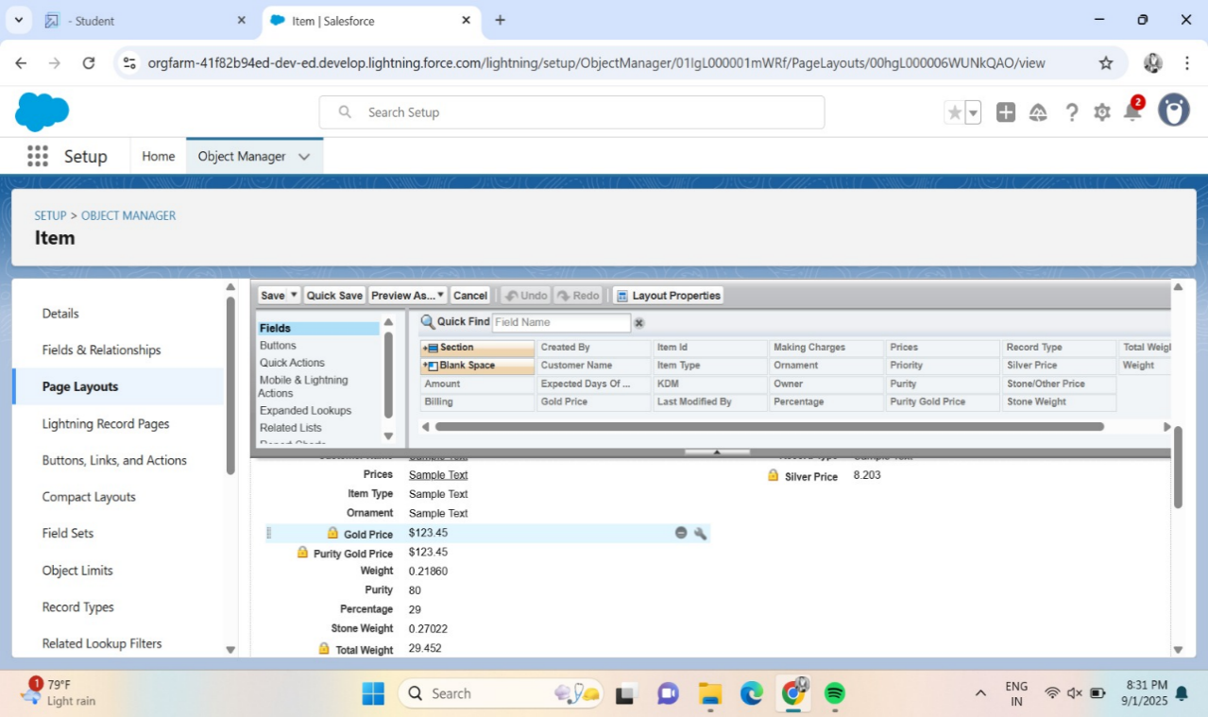

1. Name the Layout:
   * When the pop-up appears, name your layout "Page Layout for Silver".
   * Then, click Save.
2. Arrange the Fields:
   * Now, you’ll see the layout editor. Arrange the fields as shown in the Information Section (based on your requirements).
   * Remove the fields related to Gold by clicking on the "X" next to them (or using the Remove button).
   * After adjusting everything, click OK.
3. Save the Layout:
   * When you're done, click Save to finalize the layout.

**Milestone 9:PAGE LAYOUT**

**Activity 1: Create a Record Type for Gold**

**1.** Go to Setup

* Click the gear icon in the top-right corner of Salesforce.
* Select Setup from the dropdown.

2. Find the Object

* In the Quick Find box on the left, type the name of your object (e.g., Item) and click on it.

3. Create a New Record Type

* On the left sidebar, click Record Types.
* Click New to create a new record type.

4. Fill in Record Type Details

* Select Existing Record: Choose Master (this is the default record type for the object).
* Record Type Label: Enter "Gold".
* Description: Enter "Gold items information" (this helps users know what this record type is for).
* Uncheck "Make Available": This means you're not making the Gold record type available to everyone yet.
* Click Next.

5. Assign to Profiles

* Scroll down and check the boxes for Gold Smith, Worker JW, and System Administrator profiles. These are the people who will use the Gold record type.
* Click Next.

6. Apply Page Layout for Each Profile

* Select "Apply a different layout for each profile".
* For each profile (Gold Smith, Worker JW, and System Administrator), change the Page Layout to "Page Layout for Gold".
* Click Save & New if you want to create another record type (for Silver).

**Activity 2: Create a Record Type for Silver**

1. Create Another Record Type

* Repeat the same steps as in Activity 1 to create a new record type.
* For the Record Type Label, enter "Silver".
* For the Description, enter "Silver items information".

2. Assign Profiles for Silver

* Scroll down and check the boxes for the same profiles (Gold Smith, Worker JW, System Administrator).
* Click Next.

3. Apply Silver Layout

* Apply a different layout for each profile.
* For each profile, change the Page Layout to "Page Layout for Silver".
* Click Save.

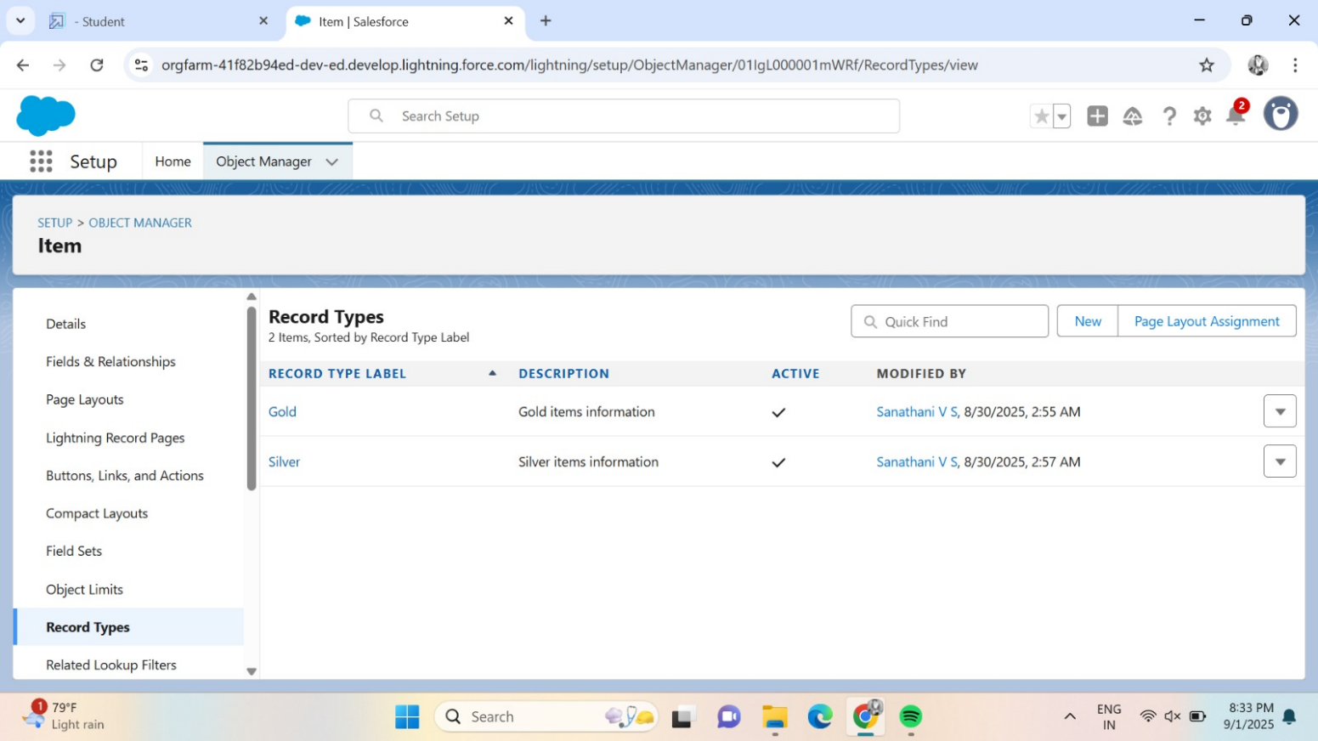

**Milestone:10 PERMISSION SETS**

**ACTIVITY 1:Creating Permission Sets**

1. Go to Setup

* Click the gear icon in the top-right corner of Salesforce.
* Select Setup.

2. Search for Permission Sets

* In the Quick Find box on the left, type "Permission Sets" and click on it.

3. Create a New Permission Set

* Click the New button to create a new permission set.

4. Fill in the Permission Set Details

* Label: Enter the label name as "Per to Worker".
* API Name: This will auto-populate once you enter the label.
* save

**Configure Object Settings in the Permission Set**

5. Select Object Settings

* Under the **Apps** section on the left, click **Object Settings**.

6. Choose the Items Object

* Click on the Items object.
* Click the Edit button.

7. Enable Record Types (Gold and Silver)

* In the Item: Record Type Assignments section, enable Gold and Silver record types.

8. Set Object Permissions

* Under Object Permissions, check the boxes for Read, Edit, and Create.

9. Save the Permission Set

* Click **Save** to save these settings.

**Assign Permission Set to Users**

10. Manage Assignment

* After saving the permission set, click Manage Assignments.

11. Add Assignment

* Click Add Assignment.

12. Select Users

* Find and select the users you created in the User Milestone who have the Worker profile.
* Click Next, then click Assign.

13. Finish

* After assigning the permission set, click Done.

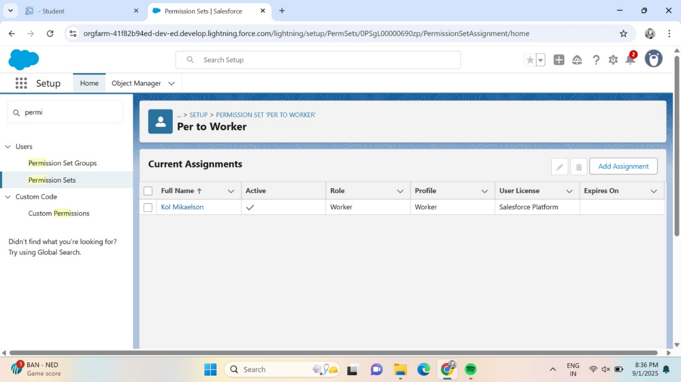

**Milestone 11:TRIGGER**

**ACTIVITY 1:Create A Trigger Handler Class**

**Code:**

 public class UpdatePaidAmountTriggerHandler {

    public static void handleBeforeInsert(List<Billing__c> newBillings) {

        for (Billing__c billing : newBillings) {

            billing.Paid_Amount__c = billing.Paying_Amount__c;

        }

    }

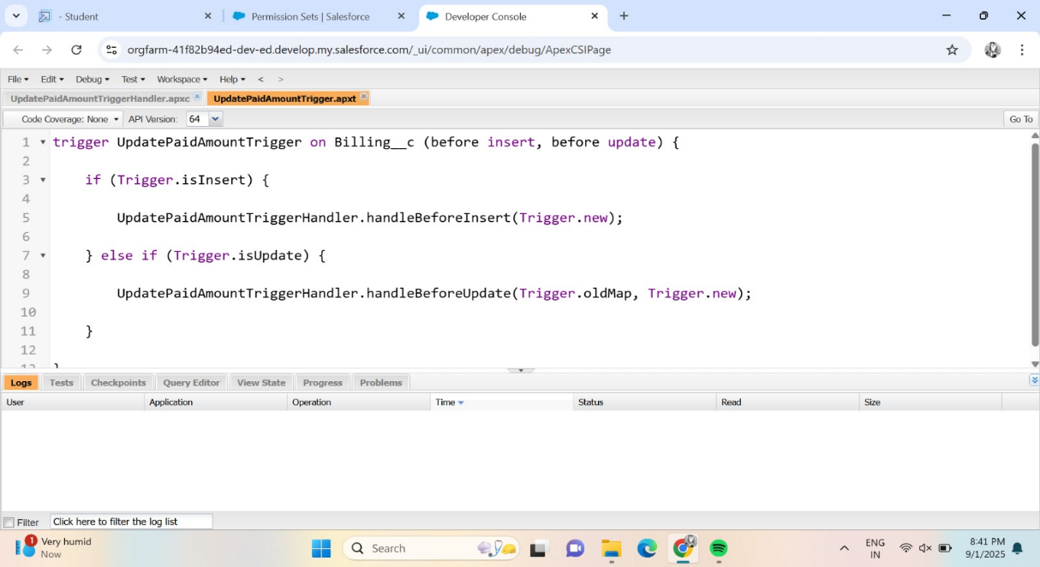

**ACTIVITY 2:Create The Trigger**

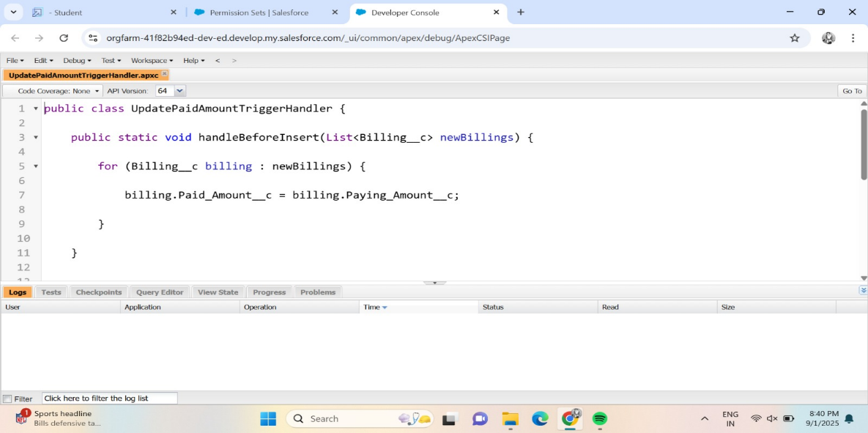

### Milestone 12: USER ADOPTION

### ACTIVITY 1:Create a Record (Jewel Customer)

1. Click on App Launcher:  
   On the left side of your screen, you'll see an icon called the App Launcher (it might look like a grid of dots). Click on it to open a list of all the apps in your system.
2. Search for "Jewelry Inventory System":  
   In the search bar, type "Jewelry Inventory System" and click on it once it appears in the search results. This opens the app.
3. Click on Drop Down and Select "Jewel Customer" Tab:  
   Inside the Jewelry Inventory System app, you'll see a drop-down menu or list of tabs at the top. Click on the drop-down, and from the list, choose the Jewel Customer tab. This tab is where you can manage your customer information.

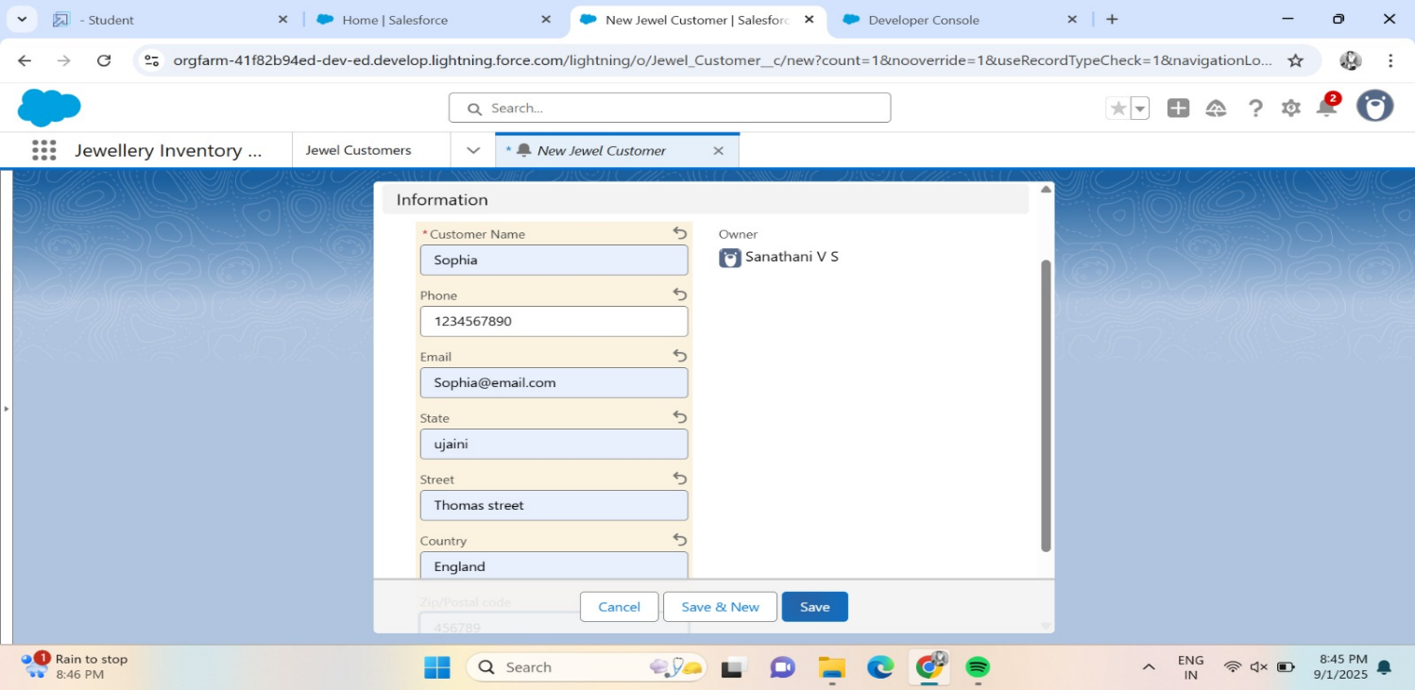

1. Click "New":  
   After you've selected the Jewel Customer tab, look for a button that says New (usually at the top of the screen). Click this to create a new customer record.
2. Fill in the Details:  
   A form will appear asking you to enter customer details (such as name, contact info, etc.). Fill out the form with the required information.
3. Click Save:  
   After entering all the customer details, click the Save button to store the information in the system.

### ACTIVITY 2:View A Record(Jeweller Customer)

1. Click on App Launcher:  
   On the left side of your screen, click the App Launcher icon (a grid of dots) to open a list of apps.
2. Search for "Jewelry Inventory System":  
   In the search bar, type "Jewelry Inventory System" and select it from the search results. This will open the Jewelry Inventory System app.
3. Click on the Jewel Customer Tab:  
   Inside the Jewelry Inventory System app, you’ll see a list of tabs at the top. Click on the Jewel Customer tab. This will show you a list of all customer records.

### 

### ACTIVITY 3:Delete A Record(Jewellry Customer)

### To **Delete a Jewel Customer Record**:

1. Click on App Launcher:  
   On the left side of your screen, click the App Launcher icon (grid of dots) to open the list of apps.
2. Search for "Jewelry Inventory System":  
   In the search bar, type "Jewelry Inventory System" and click on it to open the app.
3. Click on the Jewel Customer Tab:  
   Inside the Jewelry Inventory System app, you’ll see a set of tabs. Click on the Jewel Customer tab to view the list of customer records.
4. Click on the Arrow:  
   Find the record you want to delete. On the right side of the record, you’ll see an arrow (or a dropdown). Click on that arrow.
5. Click Delete:  
   In the dropdown menu, click Delete. This will remove that customer record from the system.

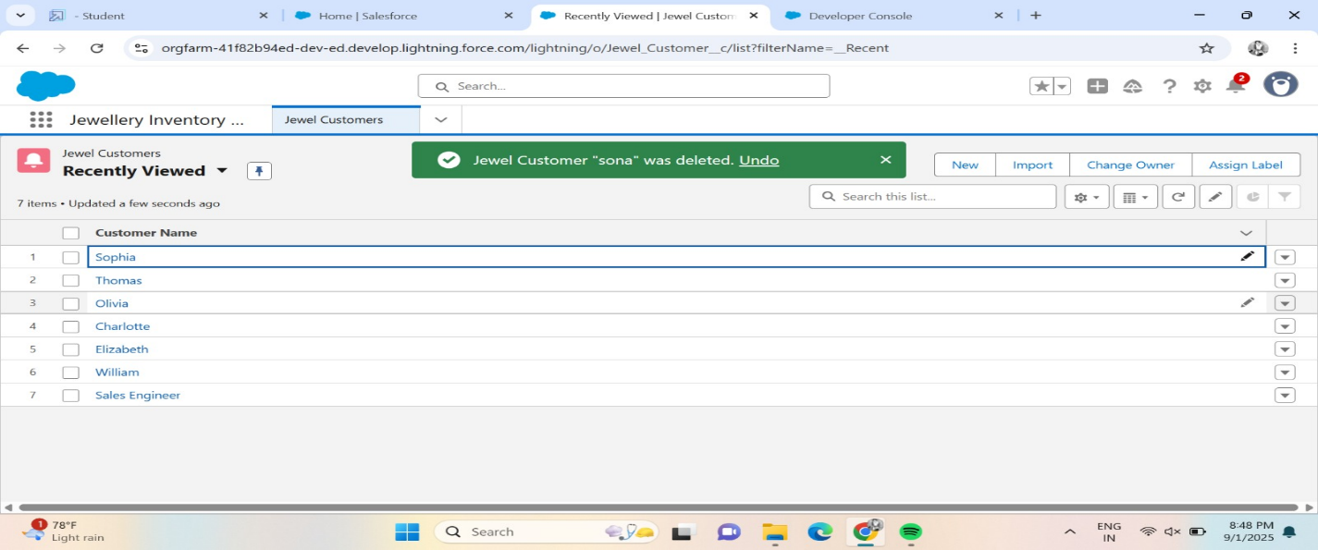

#### PHASE 5: Deployment, Documentation & Maintenance

#### Milestone 13:REPORTS

#### ACTIVITY 1:Create Report

1. Open the App: Go to the app and find the Reports tab.
2. Create a New Report: Click on New Report to start creating a report.
3. Select Report Type:
   * You can choose a report type by browsing categories.
   * Alternatively, you can search for a specific report type.
   * Once you find what you're looking for, click Start Report.
4. Customize Your Report:
   * You'll be able to add specific fields (or data) to the report. These fields are shown on the left side of the screen.
   * Pick the fields you need and drag them into the report.
5. Save or Run the Report:
   * Once you're happy with the report, either save it for future use or run it to generate the data.

#### 

#### ACTIVITY 2:REPORTS

### **1. Create a Report with "Item with Billings"**:

### 2. **Create a Report with "Billings with Item and Customer Order"**:

* Again, go to the Reports tab and click New Report.
* Search for or select "Billings with Item and Customer Order" as the report type.
* Click on Start Report.
* Customize it by adding the fields you want (e.g., billing details, items sold, customer orders, etc.).
* After setting it up, save **or** runthe report.

#### 

#### Milestone 14:DASHBOARDS

#### Activity 1: Create a Dashboard

1. Open the App: Go to the app and click on the Dashboards tab.
2. Create a New Dashboard:
   * Give your dashboard a name (e.g., "Sales Overview").
   * Click on Create.
3. Add a Component:
   * After creating your dashboard, click on Add Component.
4. Select a Report:
   * Choose a report that you want to display on the dashboard (e.g., "Item with Billings").
   * Click Select to choose the report.
5. Add the Report:
   * After selecting the report, click Add to add it to the dashboard.
6. Save the Dashboard:
   * Click on Save to save the dashboard.
   * Once saved, click Done to finish.

### **Activity 2: Create Another Dashboard (Repeat Steps from Activity 1)**

* Repeat the same steps as in Activity 1 to create another dashboard.
* Give it a different name, add a component (report), save it,

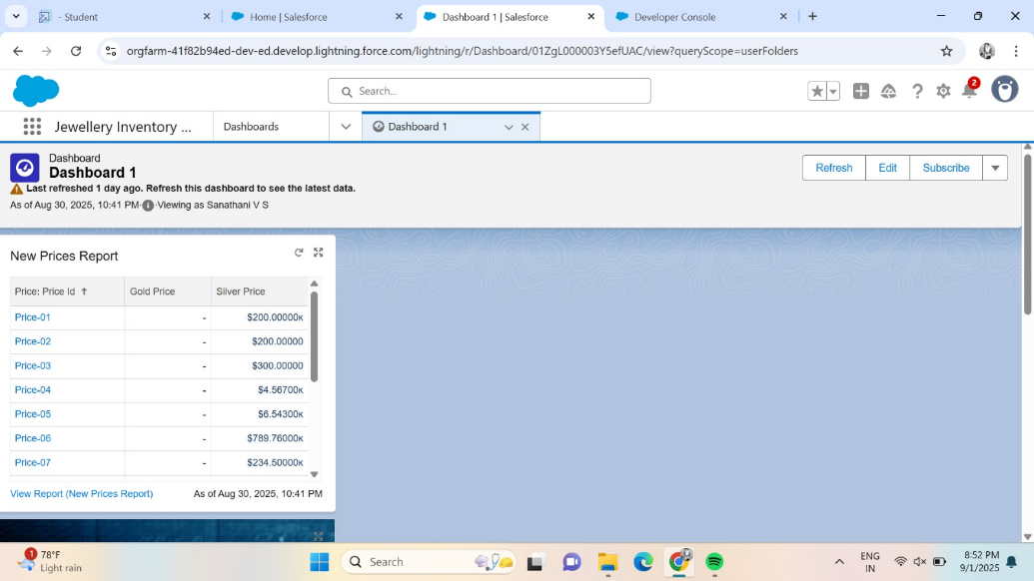

#### Milestone 15:FLOWS

#### ACTIVITY 1:CREATE A FLOW

### **Steps to Create a Flow in Salesforce:**

1. Go to Setup:
   * Open Setup in Salesforce.
   * In the Quick Find box, type "Flow" and click on Flow.
2. Create a New Flow:
   * Click on New Flow.
   * Select Record-triggered Flow and click Create.
3. Choose the Object:
   * From the Object dropdown, select "Billing".
   * Set the flow trigger to "A record is Created or Updated".
   * Under Optimize the flow for, select "Actions and Related Records".
   * Click Done.
4. Switch to Free-form Layout:
   * Change the flow layout from Auto-layout to Free-form by selecting it.
5. Create a Text Template:
   * In the Toolbox, find the Manager option and click on New Resource.
   * Choose Text Template as the resource type.
   * Enter the API Name as "Email Body".
   * Change the View from Rich Text to Plain Text.
   * In the Body field, paste the following syntax:
   * **Hello**
   * **Customer Name: {!$Record.Item__r.Customer_Name__r.Name}**
   * **Here are the details for the item you purchased with Jewellery Inventory System:**
   * **Item Type: {!$Record.Item__r.Item_Type__c}**
   * **Ornament: {!$Record.Ornament__c}**
   * **Weight: {!$Record.Weight__c} grams**
   * **Amount: {!$Record.Amount__c}**
   * Click Done.
   * 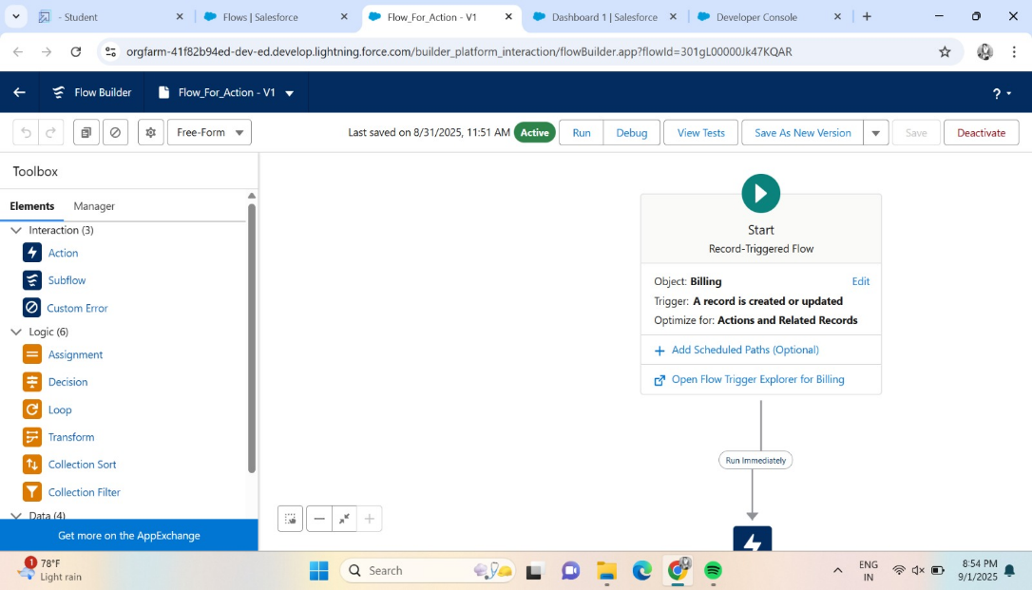

Add an Action to Send an Email:

* + In the Elements section, drag the Action element to the flow canvas.
  + In the action search bar, search for "Send Email" and click on it.
  + Set the Label as "Notice" (the API name will auto-populate).
  + Enable the Body field and set the value to the Text Template you just created.
  + For Recipient Address, select the email field from the record ({!$Record.Item__r.Customer_Name__r.Email__c}).
  + Set the Subject to "Welcome to Jewelry Inventory System".
  + Click Done.

1. Connect the Flow Elements:
   * Drag a Path from the Start element to the Action element.
2. Save and Activate the Flow:
   * Click Save and give your flow a Label. The API Name will be auto-populated.
   * Finally, click Activate to turn the flow on.

**CONCLUSION:**

By leveraging the Salesforce platform, the project successfully established an efficient, transparent, and user-friendly system for managing jewellery inventory, customer relationships, and sales operations. Through streamlined workflows and real-time coordination among staff, suppliers, and customers, the project significantly improved operational efficiency and customer experience.

The project **“Jewellery Management System using Salesforce CRM”** has been successfully implemented and highlights the effective use of Salesforce technology in automating and optimizing business processes within the retail jewellery sector.

### **PROJECT ACHIEVEMENTS:**

* **Streamlined Inventory Management**: Simplified tracking and management of jewellery stock across multiple categories and locations.
* **Automation of Business Processes**: Implemented custom objects, Flows, and Apex triggers to automate tasks such as order processing, stock alerts, and billing.
* **Improved Reporting & Analytics**: Leveraged dashboards and reports to gain real-time insights into sales, customer behavior, and inventory turnover.
* **Secure Role-Based Access**: Ensured data security and usability with a customized Lightning App, Home Page, and role-specific permissions

### **STUDENT LEARNING OUTCOMES:**

* **Hands-On CRM Customization**: Gained practical experience in developing custom Salesforce objects, workflows, and automation.
* **Business Process Understanding**: Learned how to map real-world jewellery business processes into CRM systems.
* **Team Collaboration**: Collaborated effectively in requirements gathering, system design, development, and testing.
* **Professional Tool Exposure**: Worked with industry-standard tools and methodologies, enhancing readiness for enterprise environments.

**FUTURE SCOPE:**

* **Mobile App Integration**: Enable mobile access for sales staff and customers to view inventory and manage orders on the go.
* **AI & Analytics**: Use predictive analytics to forecast customer buying trends and manage stock efficiently.
* **Third-Party Integration**: Connect with ERP systems, payment gateways, and e-commerce platforms for end-to-end business automation.
* **Scalability Across Branches**: Expand the system for use across multiple store locations, ensuring centralized management and reporting.